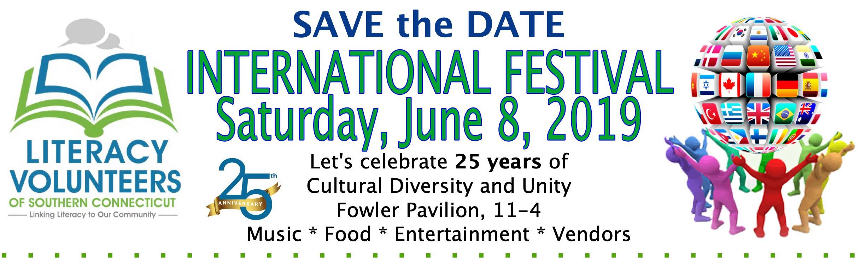
INTERNATIONAL ENTERTAINMENT APPLICATION
Milford Rotary Pavilion, Fowler Field, Downtown Milford, CT 06460

Name/Company Name: ____________________________________________________________________________________________

Address:_____________________________________________________________________________________________________________

City: __________________________________________ State: _______________ Zip: ____________________

Cell Phone: __________________________________________ E-mail Address: ______________________________________________

International Entertainment: _______________________________________________________________________________________

Will you require electricity? YES____NO_____ If yes, please describe: ________________________________________

Applicant agrees to indemnify, defend, and hold harmless Literacy Volunteers of Southern CT, its officers, directors, volunteers, officials, employees, agents, from and against any and all liabilities, claims, suits and causes of action of whatever nature or type (including but not limited to causes of action based upon tort, strict liability or otherwise), and all attorney fees, costs, and expenses. This indemnification is absolute, personal to the Applicant and is not limited by the insurance coverage, which the Applicant may have in place. Applicant understands that Literacy Volunteers of Southern CT are under no obligation to provide insurance to cover the Vendor from loss from any cause to any of Applicants’ property. By checking “YES, I AGREE” on the page, the applicant agrees to hold Literacy Volunteers of Southern CT harmless for any liability or loss whatsoever.

- I give the International Festival committee permission to photograph my work and space and allow them to use these photographs in marketing of this show.

- All assignments are the final decision of the committee.

- No refunds or substituted shows will be allowed. We are not responsible for lost or stolen items.

- I have full read and understand each and every item set forth in the general information/regulations with this contract and agree to be known by the same to the extent as is fully set forth herein.

YES, I AGREE: _______________________ DATE:___________________________________________________________

NAME (Please Print):____________________________________________________________________________________

SIGNATURE:________________________________________________________

Please mail your Application to LVSCT, 16 Dixon St. Milford, CT 06460 by June 1 to secure your space.

*Sponsored by Literacy Volunteers of Southern CT, International Festival, 25th Anniversary Celebration

INTERNATIONAL CRAFT VENDOR APPLICATION
Milford Rotary Pavilion, Fowler Field, Downtown Milford, CT 06460

Name/Company Name: ____________________________________________________________________________________________

Address:_____________________________________________________________________________________________________________

City: __________________________________________ State: _______________ Zip: ____________________

Cell Phone: __________________________________________ E-mail Address: ______________________________________________

International Product/Art: _________________________________________________________________________________________
(Please tie your craft/items into an international theme)
Will you require electricity? YES____NO_____ If yes, please describe: ________________________________________

Vendor agrees to indemnify, defend, and hold harmless Literacy Volunteers of Southern CT, its officers, directors, volunteers, officials, employees, agents, from and against any and all liabilities, claims, suits and causes of action of whatever nature or type (including but not limited to causes of action based upon tort, strict liability or otherwise), and all attorney fees, costs, and expenses. This indemnification is absolute, personal to the Vendor and is not limited by the insurance coverage, which the Vendor may have in place. Vendor understands that Literacy Volunteers of Southern CT are under no obligation to provide insurance to cover the Vendor from loss from any cause to any of Vendors’ property. By checking “YES, I AGREE” on the following page, the exhibitor agrees to hold Literacy Volunteers of Southern CT harmless for any liability or loss whatsoever.

- I give the International Festival committee permission to photograph my work and space and allow them to use these photographs in marketing of this show.

- All space assignments are the final decision of the committee.

- No refunds or substituted shows will be allowed. We are not responsible for lost or stolen items.

- I have full read and understand each and every item set forth in the general information/regulations with this contract and agree to be known by the same to the extent as is fully set forth herein.

- I agree to provide Literacy Volunteers of Southern CT, with a non-refundable fee of $30.

- Vendors keep 100% of their sales.

YES, I AGREE: _______________________ DATE:___________________________________________________________

NAME (Please Print):____________________________________________________________________________________

SIGNATURE:________________________________________________________

Please mail your $30 payment and completed Vendor Application to LVSCT, 16 Dixon St. Milford, CT 06460 by June 1
to secure your space. Payments may be made by Check or Money Order only

*Sponsored by Literacy Volunteers of Southern CT, International Festival, 25th Anniversary Celebration
FOOD VENDOR APPLICATION
Milford Rotary Pavilion, Fowler Field, Downtown Milford, CT 06460

Name/Company Name: ____________________________________________________________________________________________

Address:_____________________________________________________________________________________________________________

City: __________________________________________ State: _______________ Zip: ____________________

Cell Phone: __________________________________________ E-mail Address: ______________________________________________

Food items: __________________________________________________________________________________________________________

Will you require electricity? YES____NO_____ If yes, please describe: ________________________________________

Vendor agrees to indemnify, defend, and hold harmless Literacy Volunteers of Southern CT, its officers, directors, volunteers, officials, employees, agents, from and against any and all liabilities, claims, suits and causes of action of whatever nature or type (including but not limited to causes of action based upon tort, strict liability or otherwise), and all attorney fees, costs, and expenses. This indemnification is absolute, personal to the Vendor and is not limited by the insurance coverage, which the Vendor may have in place. Vendor understands that Literacy Volunteers of Southern CT are under no obligation to provide insurance to cover the Vendor from loss from any cause to any of Vendors’ property. By checking “YES, I AGREE” on the following page, the exhibitor agrees to hold Literacy Volunteers of Southern CT harmless for any liability or loss whatsoever.

- I give the International Festival committee permission to photograph my food, people, space and allow them to use these photographs in marketing of this show.

- All space assignments are the final decision of the committee.

- No refunds or substituted shows will be allowed. We are not responsible for lost or stolen items.

- I have full read and understand each and every item set forth in the general information/regulations with this contract and agree to be known by the same to the extent as is fully set forth herein.

- I agree to provide Literacy Volunteers of Southern CT, with a non-refundable fee of $100.

- Food Vendors keep 100% of their sales.

Please mail your $100 payment to LVSCT, 16 Dixon St. Milford, CT 06460 by June 1.
Please send the signed Vendor Application and payment to secure your space.

YES, I AGREE: _______________________ DATE:___________________________________________________________

NAME (Please Print):____________________________________________________________________________________

SIGNATURE:________________________________________________________

*Sponsored by Literacy Volunteers of Southern CT, International Festival, 25th Anniversary Celebration
25th Anniversary Celebration
SPONSORSHIP APPLICATION
Milford Rotary Pavilion, Downtown Milford, CT 06460

[ ] International Sponsor $2500 donation
- 20 FREE admission to International Festival and 20 FREE Registrations for Neon Night Run
      - Your name displayed on marketing material and verbal recognition at Festival
- International Day signage at Stage and lawn signs
      - Listed on web site, social media
      - Table to promote business

[ ] World Sponsor $1000 donation
- 10 FREE admission to International Festival and 10 FREE Registrations for Neon Night Run
- Your name displayed on marketing material and verbal recognition at Festival
- International Day signage at Stage and lawn signs
      - Listed on web site, social media
      - Table to promote business

[ ] Diversity Sponsor $500 donation
- 10 FREE admission to International Festival
- Your name displayed on marketing material and International Day signage
• Listed on web site, social media
• Table to promote business

[ ] Ethnic Sponsor $250 donation
• International Day signage
• Listed on web site, social media
- Table to promote business

[ ] Literacy Sponsor $100
• Listed on web site, social media
- Table to promote business

[ ] Other Donation in the amount of $ __________

Company/Sponsor Name: ________________________________________________________________________

Address: ______________________________________________________________________________________

Phone / e-mail: _________________________________________________________________________________

Contact Name: _________________________________________________________________________________
Please make checks payable to: Literacy Volunteers of Southern Connecticut or LVSCT and mail to 16 Dixon St. Milford, CT 06460
Literacy Volunteers is a 501C3 nonprofit organizations. Employer identification #06-1402186. All donations are tax deductible. Consult your tax advisor for more information.

VENDOR/SPONSORSHIP ADDITIONAL INFORMATION:

Food Vendor Fee $100.00
- Please check in at Registration Table and direct questions to Heather Carolan, Rose Rodrigues or Casey Schwing.
- If you plan to sell any food items, please be sure to contact the Milford Health Department for your application and applicable fee. Food Licenses will be required on the day of the event and must be displayed at the International Festival.
Milford Health Department
82 New Haven Avenue
Milford, CT 06460
ci.milford.ct.us/health-department-0
203-783-3285

Craft Vendor Fee $30.00
- Please check in at Registration Table and direct questions to Beth Barsky, Gayle McMillan.
- Craft Vendor items must have International tie to their products.

Sponsorship Tables
- Please check in and direct questions to Registration Table.

Food Vendors, Craft Vendors and Sponsorship Tables
- Set up will be held on Saturday, June 8, 9:30 am.
- Vendors and Sponsors must be ready by 10:30 am on Saturday, June 8, 2019.
- Vendors and Sponsor tables must be staffed at all times.
- Vendors and Sponsors will provide own tables and chairs.
- Vendors and Sponsors are responsible for keeping their space attractive and safe during the day and cleaning up their space afterwards, including removal of garbage.
- Break down at 4:00 p.m.
- The event is rain or shine. There will be no rain date.
- Contact director@lvsct.org with questions or call 203-878-4800.

*Sponsored by Literacy Volunteers of Southern CT, International Festival, 25th Anniversary Celebration

